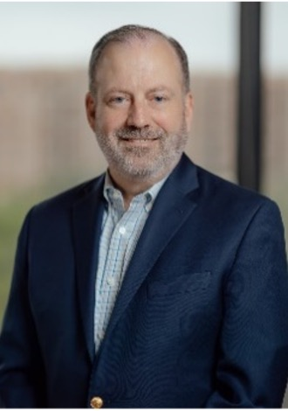
Mark Coughlin, FACHE
Principal
Capital Healthcare Planning

Mark is a Principal at Capital Healthcare Planning. He has more than 30 years of experience assisting healthcare clients, including hospitals and health systems, academic medical centers, physician groups, international healthcare operators and payers on a wide variety of strategic, financial, capital and operational issues. He specializes in developing practical, execution-focused solutions that align strategic planning, capital investment, and care delivery operations to achieve sustainable change. His background also includes executive leadership roles in international hospital development, physician practice management, and for-profit health system operations, giving him a unique perspective on how strategic plans succeed—or fail—at the point of implementation.

Mark is a Fellow with the American College of Healthcare Executives and is a frequent speaker at national and regional conferences on a variety of strategic issues.

