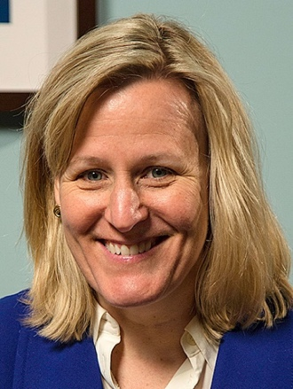

Jennifer Healey, LMHC, MFT

Vice President of Operations

Care New England

Jennifer Healey, LMHC, MFT, joined Care New England in 2020 and currently serves as Vice President of Operations for Ambulatory and Outpatient Behavioral Health at Butler Behavioral Health and Care New England Medical Group. In this role, she provides operational leadership across ambulatory and outpatient behavioral health programs, including services at Butler Hospital and Women & Infants Hospital. She works collaboratively with service line leaders and multidisciplinary teams to strategically develop and refine programs, expanding access to behavioral health services.
Jen brings extensive experience in behavioral health leadership and clinical services, with particular expertise in substance use treatment, Dialectical Behavior Therapy (DBT), and family systems, across acute care, partial hospitalization, and a myriad of outpatient programs. As a family therapist, Jen spent 23 years in private practice providing care to military couples and families, adolescents, and adults. Her clinical background includes DBT skills training and extensive therapeutic work with individuals, couples, and families.
Prior to joining Care New England, Jen served as Executive Director of Integrated Behavioral Health at CharterCARE and Director of Clinical Services at Southcoast Behavioral Health. She also held the position of Associate Director of Outpatient Services and New Business Development at Continuum Behavioral Health, and Director of Adolescent Services at Fuller Memorial Hospital while maintaining an outpatient psychotherapy practice in Middletown, Rhode Island.
Jen earned a Bachelor of Arts and Master of Science in Counseling and Human Relations from Villanova University, followed by a Master of Science in Marriage and Family Therapy from the University of Rhode Island. She also completed advanced graduate studies at Rhode Island College.
She is a member of the American Mental Health Counselors Association and the American Association for Marriage and Family Therapy. She also serves as Human Rights Chairperson for the ARC of Blackstone Valley.
Throughout her career, Jen has focused on strengthening behavioral health services through collaborative leadership, program development, and a commitment to expanding access to high-quality, patient-centered care.

